Software Design Document
Advanced Tic-Tac-Toe with SQLite and AI

1. Introduction
1.1 Purpose of this Document
This document outlines the design of an advanced Tic-Tac-Toe game implemented in C++ with SQLite for user management and game history, and AI opponents with varying difficulty levels. It serves as a blueprint for developers, testers, and maintainers to understand the system's architecture, functionality, and implementation details.

1.2 Scope of the System
The system is a console-based Tic-Tac-Toe game supporting single-player (against AI) and two-player modes. It includes user registration/login, game history tracking, and AI with easy, medium, and hard difficulty levels. The system uses SQLite for persistent data storage and is implemented in C++.

1.3 Audience
This document is intended for developers, system architects, testers, and stakeholders involved in the development, maintenance, or extension of the Tic-Tac-Toe application.

1.4 Definitions, Acronyms, and Abbreviations
- SQLite: Lightweight relational database management system.
- AI: Artificial Intelligence, referring to computer-controlled opponents.
- CLI: Command Line Interface.
- UML: Unified Modeling Language.

1.5 References
- SQLite Documentation: https://www.sqlite.org/docs.html
- C++ Standard Library Reference: https://en.cppreference.com/w/
- UML Specification: https://www.omg.org/spec/UML/

1.6 Document Overview
This document covers the system overview, architecture, data design, module details, UML diagrams, UI design, security, assumptions, and appendices.

2. System Overview
2.1 High-Level Description
The Tic-Tac-Toe system is a console-based game where users can register/login, play against another player or AI, and view game history. It uses SQLite to store user credentials and game results, with AI logic for three difficulty levels.

2.2 System Context
The system operates as a standalone C++ application with SQLite as the database. Users interact via a CLI, inputting choices and moves. The system context includes:
- Users: Players interacting via the console.
- Database: SQLite for storing user data and game history.
- AI: Internal logic for computer opponents.

2.3 Key Features / Capabilities
- User registration and login with password hashing.
- Two-player and single-player (AI) game modes.
- AI with easy (random), medium (reactive), and hard (minimax) difficulties.
- Game history tracking and retrieval.
- Input validation and basic SQL injection prevention.

3. System Architecture
3.1 Architectural Design
The system follows a modular design with the following components:
- User Management: Handles registration and login.
- Game Logic: Manages board state, moves, and win/draw conditions.
- AI Logic: Implements easy, medium, and hard AI strategies.
- Database Access: Interacts with SQLite for data storage/retrieval.
- CLI Module: Manages user input/output.

3.2 Component Diagram
[Placeholder for Component Diagram]
(See Section 6.4 for the UML Component Diagram)

3.3 Deployment Architecture
The system is a standalone executable running on a single machine with SQLite as an embedded database. No network or server deployment is required.

3.4 Technologies and Tools Used
- C++: Core programming language.
- SQLite: Database for user and game history storage.
- SQLite3 C API: For database operations.
- Standard Template Library (STL): For vectors and strings.

4. Data Design
4.1 Database Schema
The system uses two SQLite tables:
- Users:
- id: INTEGER PRIMARY KEY AUTOINCREMENT
- username: TEXT UNIQUE
- password: TEXT (hashed)
- History:
- id: INTEGER PRIMARY KEY AUTOINCREMENT
- username: TEXT
- result: TEXT
- date: TIMESTAMP DEFAULT CURRENT_TIMESTAMP

ER Diagram:
[Placeholder for ER Diagram]

4.2 Data Dictionary
- Users Table:
- id: Integer, unique identifier, auto-incremented.
- username: String, unique, max 255 characters.
- password: String, hashed password (simple sum of ASCII values).
- History Table:
- id: Integer, unique identifier, auto-incremented.
- username: String, references user, max 255 characters.
- result: String, game outcome (e.g., "Win vs AI"), max 255 characters.
- date: Timestamp, records game time.

4.3 Data Flow Diagrams
[Optional Placeholder for Data Flow Diagram, not included for brevity]

5. Detailed Module Design
5.1 Module Overview
5.1.1 User Management
Handles user registration and login, including password hashing and SQL query execution.

5.1.2 Game Logic
Manages the Tic-Tac-Toe board, validates moves, checks for winners/draws, and saves game results.

5.1.3 AI Logic
Implements three AI levels:
- Easy: Random valid moves.
- Medium: Checks for winning/blocking moves, else random.
- Hard: Uses minimax algorithm for optimal moves.

5.1.4 Database Access
Provides functions to execute SQL queries, set up tables, and store/retrieve data.

5.1.5 UI Logic / CLI Module
Handles console-based input/output, including menus, board display, and user prompts.

5.2 Functions and Interfaces
- simpleHash(const string&): string
- Input: Password string
- Output: Hashed password (sum of ASCII values)
- Description: Converts password to a simple hash.
- executeSQL(const string&): bool
- Input: SQL query string
- Output: True if successful, false otherwise
- Description: Executes SQL query on SQLite database.
- registerUser(string&): bool
- Input: Username reference (updated with input)
- Output: True if registration succeeds
- Description: Registers a new user with hashed password.
- loginUser(string&): bool
- Input: Username reference (updated with input)
- Output: True if login succeeds
- Description: Authenticates user credentials.
- displayBoard(): void
- Input: None
- Output: Displays game board to console
- checkWinner(): char
- Input: None
- Output: 'X', 'O', or ' ' (no winner)
- Description: Checks rows, columns, diagonals for a winner.
- easyAIMove(): pair<int, int>
- Input: None
- Output: Row, column of random valid move
- mediumAIMove(char, char): pair<int, int>
- Input: AI and player symbols
- Output: Row, column of strategic move
- hardAIMove(char, char): pair<int, int>
- Input: AI and player symbols
- Output: Row, column of optimal move (minimax)
- saveGameHistory(const string&, const string&): void
- Input: Result, username
- Output: None
- Description: Saves game outcome to History table.
- viewHistory(): void
- Input: None
- Output: Displays user’s game history.

6. UML Diagrams
Below are the UML diagrams with a brief explanation of each UML diagram type

6.1 Class Diagram
Purpose: Represents the static structure of the system, showing classes, their attributes, methods, and relationships (e.g., composition, association).
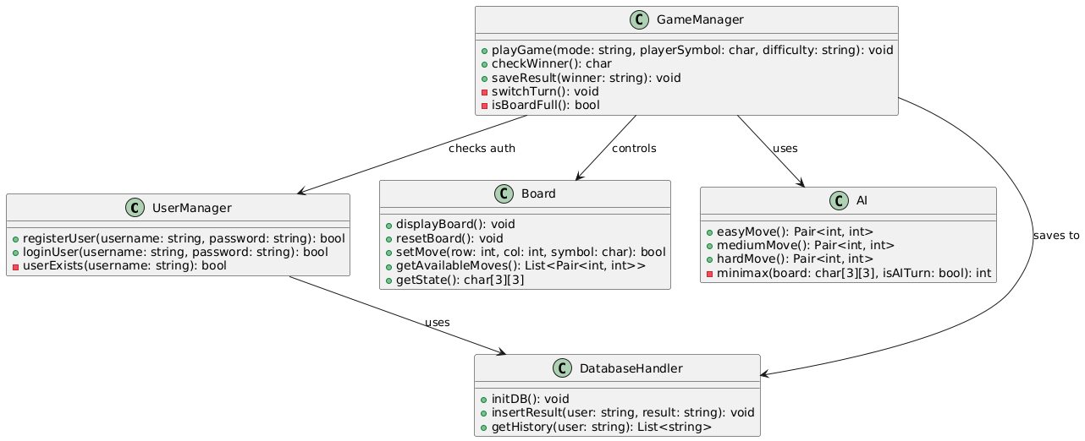
6.2 Sequence Diagrams
Purpose: Illustrates dynamic interactions between objects over time, showing method calls and message passing for key scenarios (e.g., game flow, user login).
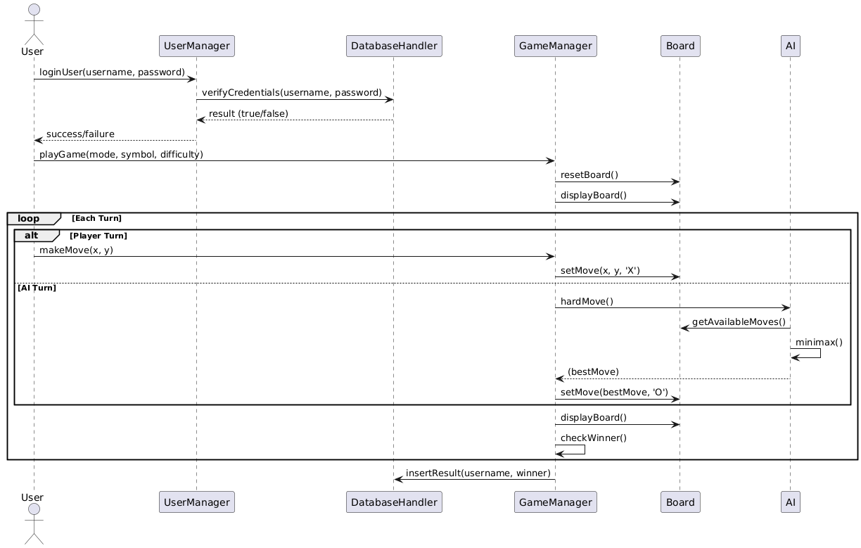
6.3 Activity Diagrams
Purpose: Models workflows or processes, detailing the steps in complex logic (e.g., AI decision-making, game loop).
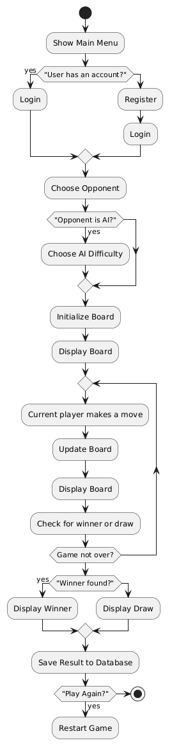

6.4 Component Diagram
Purpose: Shows the organization and dependencies of system components (e.g., User Management, Game Logic, Database Access).
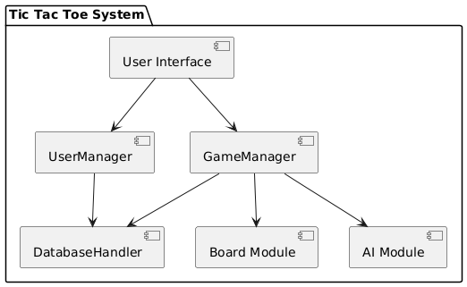
6.5 Use Case Diagram
Purpose: Depicts system functionality from the user’s perspective, showing actors (e.g., Player, AI) and use cases (e.g., Play Game, View History).
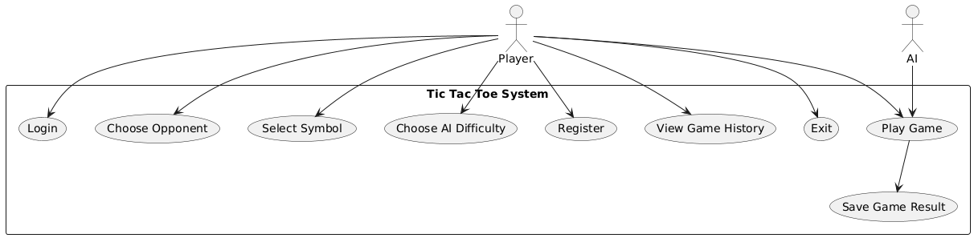
7. User Interface Design
7.1 UI Mockups or Wireframes
The system uses a CLI, with no graphical UI. Example interaction:

